10.103: a) See Problem 10.92; 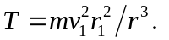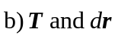 are always antiparallel, so
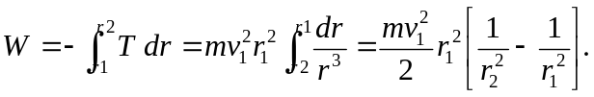
c) 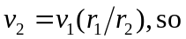
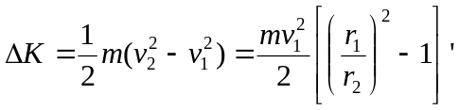
which is the same as the work found in part (b).

